Innovation Partnership
The Norwegian Coastal Administration Pilot Service

Appendix 1B
Background and today`s situation

Background
The Norwegian Coastal Administration (NCA) Pilot Services contributes to ensuring the safety at sea and protection of the environment by providing the vessel's crew with the necessary maritime expertise and knowledge of littoral waters. The service is operational and available 24 hours a day, all year round. The pilot service has stations from Svalbard in the north to the Swedish border in the south. It is divided into 24 pilot stations, seven pilot regions, with approximately 290 pilots.

Introduction of electronic navigation
In recent decades there has been a development in digitalization in the maritime sector. This has led to the introduction of a number of support systems for the navigator, known as electronic navigation. Elements of electronic navigation include radar, electronic chart display and information system (ECDIS), AIS (Automatic Identification System), and Position, Navigation and Timing (PNT) service. The introduction of near real-time presentation of the position of the vessel using GNSS, where GPS (Global Positioning System) is the most common PNT service, has increased the safety of navigation at sea. It has also changed how we practice navigation and the vessels operating patterns. Navigators traditionally worked hard to find and fix the position of the vessel, but with the introduction of electronic navigation the navigators are today monitoring the presented position. Electronic navigation could also induce increased vulnerability related to data quality and signal interference (jamming and spoofing). The pilot`s dilemma, however, is if he can trust the given position or not?

Operational margins are pushed
The ships increase in size and weight, being more custom built to solve demanding maritime operations. The ports and fairways more or less reminds the same which in turn give smaller margins and safety limits are pushed. At the same time, due to increasingly extreme conditions, the weather presents increasing challenges, being unstable and more unpredictable. All contributes to an increased pressure towards the NCA, and the Pilot Services (NPS), to deliver pilotage in increasingly more complex and challenging situations.

Content
Background 2
Introduction of electronic navigation 2
Operational margins are pushed 2
Today's situation 4
Summary of questionnaire 5
Types of Pilot operations 6
1. Regular pilotage 6
2. Pilotage with small margins 8
3. Remote navigational assistance by the pilot 9
NCA Pilot Service thoughts on future systems 10

Today's situation
The pilot's expertise and extensive local knowledge are the foundation of the guidance carried out onboard. Together with this extensive knowledge, the pilot makes use of various support tools to further improve the decision-making process. Many of these tools are digitalized, being collectively known as Portable Pilot Unit (PPU). PPU is a collective term for sensors, display/display tools (PC, tablet), software and electronic maps (Electronic Navigational Charts - ENC).
Portable Pilot Unit (PPU)
Sensors
Display
Software (ECS)
Charts
Pilot Plug
External sensors
iPad
Njord Pilot
ENC
Hydrographic Service
Figure 1 Support tools for the Pilots
The support system of today consists of an iPad with a custom-made Electronic Chart System (ECS, “Njord Pilot” by SevenCs). Two primary sensors are part of the support system;

- Pilot Plug Connectors (personal equipment, one for each pilot)
- Independent sensor for robust and accurate positioning, multi-constellation GNSS with RTK (one independent sensor in each pilot region, used by pilots if needed in the operation).

NPS uses iPad Pro as a main tool, and several other administrative tools for the pilots are customized for the iPad. In 2016, NPS signed a contract with SevenCs to develop its own software for electronic chart systems (ECS), especially adapted to our needs, better known as Njord Pilot by SevenCs. Primar (Primar ENC) provides official approved electronic nautical charts.

Summary of questionnaire
NCA has conducted a questionnaire amongst NPS pilots as preparations and a foundation for this project. 141 pilots participated. We would like to highlight the following findings from the report;

- On a regular pilotage (without any unforeseen severe critical situations) 85 % of the pilots report that they have no need for a support system. (Possible root cause, pilots navigate either by visual means, and/or radar as their primary means of navigation)
- 97 % of the pilots assess the support system as “an extra safety barrier”.
- 76 % of the pilots would like to use a support system during critical operations and demanding operations, e.g. when margins are pushed, the weather situation is demanding, traffic density high, ship and equipment conditions poor and training and communication level with/on crew low.
- 70 % of the pilots assess that their own (navigation) systems are partly better than the ships own equipment, and 12 % is 100 % confident that their systems are better than the ships.
- Almost 80 % of all the pilots points to the uncertainty towards the quality of the data from the pilot plug as the biggest concern to their system.
- 76 % of all pilots have experienced loss of GPS signal on the ships' systems
- 54 % of all pilots have experienced loss of GPS signal on their own system
- 70 % of all pilots have experienced that the ships position has been presented incorrectly in comparison with optical and radar control
- When the pilots were asked how often they have experienced loss of GPS signal on different systems, they reported:
  - Never, 4 %
  - 1 – 10 times, 70 %
  - More than 10 times, 26 %
- When the pilots where asked how often they have experienced errors on static data (e.g. offset, AIS) they reported:
  - Never, 9 %
  - 1 – 15 times, 65 %
  - More than 15 times, 26 %
- When the pilots were asked to prioritize the “tools” they used for their decision basis (on a regular, average, pilot mission) , they answered:
  - Their vision
  - Vessels radar
  - “Pilot book and marks” (visual descriptions they have memorized)
  - Pilot iPad
  - Vessel ECDIS
  - Vessels conning - display / indicators
  - Pilot Plug (portable sensor)
  - Independent sensor (multi-constellation GNSS with RTK)

Types of Pilot operations

The pilot operations (pilotages) have largely varied. The span can be described from regular pilotage to special operation pilotage with small margins and complex circumstances. Regular pilotage can be further divided into longer inshore coastal transits (hours and days onboard) and shorter harbor pilotage (approximately 30 minutes).

Coastal pilotage is in general with approximately 100 meters long conventional vessels in demanding littoral waters.
Special operation pilotage normally include oilrigs and other types of construction ships where the margins are small. You will find large cruise liners in both coastal and harbor pilotage, underlining the challenges one can face with these ships in rather small harbors and narrow passages along the Norwegian coast.

This document describes three types of pilotage to inform the reader of the span and challenges of pilotage operations:
- Regular pilotage
- Pilotage with small margins and
- Remote navigation assistance (remote pilotage)

Regular pilotage
Pilotage that requires a minimum of preparations in advance is seen as a “standardized operation” for a pilot. Type of ship and the nature of the assignment vary a lot based on geographical location. This is also the case with boarding arrangements; we utilize everything from a pilot ladder, a simple gangway, and pilot boats to helicopters to embark. The pilotage starts when the pilot meets the captain physically on the bridge for a master-pilot information exchange (MPX). This is often a very critical situation, as the pilot and master have to concentrate fully on the fairway, traffic, cooperation and situation from the moment when the pilot enters the bridge. The pilot communicates not only with the master, but also with other people from the crew. This is done verbally and non-verbally. The pilots experience large shortfalls amongst mariners concerning english, therefore visualising is essential.

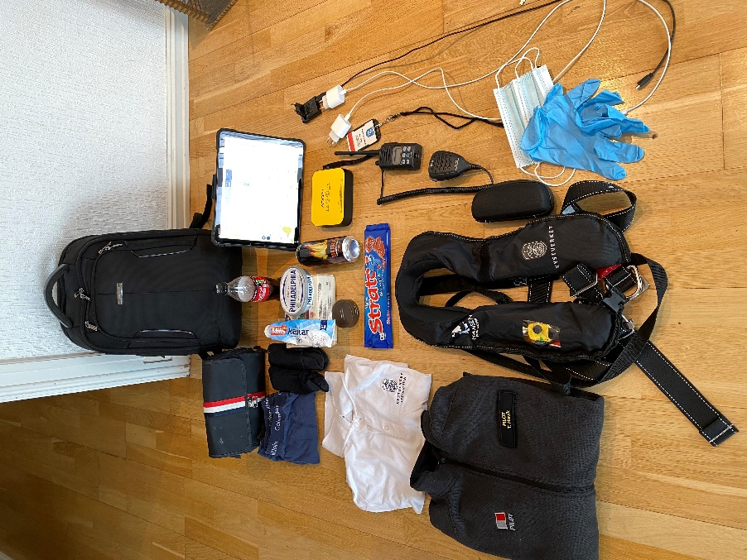
A pilot assignment like this can last from a few hours to days; this includes preparations, transport, assignments and follow-up work. The work schedule for a Pilot is unpredictable and there will often be new assignments allocated to the pilot during pilotage. This requires that the pilot needs to be prepared to be on the move for a long period of time where required rest hours might be on different locations such as pilot-station, hotels, apartments, cabins, etc. The pilot never knows when he/she returns to home/pilot-station and therefor needs to include personal effects in additional to the standard equipment. This may be food, beverages, warm clothes and a change of clothes. Standard equipment and personal effects have to fit in the pilot bag because “one bag” is the only manageable way with all the different and sometimes challenging types of boarding, harbour and travel situations. An example of the content is shown in Picture 1
Picture 1 example of the content in the pilots backpack

In a regular pilotage support, tools are not vital to safe conduct of the operation, but is more seen as a contribution to an improved safety to the operation, and constitutes an important tool when unforeseen incidents occur. In addition to the general challenge and concern, characterised by all maritime operations, weather, wind, current and visibility are general challenges and concerns. Today the challenges which the pilot experiences when conducting a “regular pilotage” and his/her use of support tools are the following:

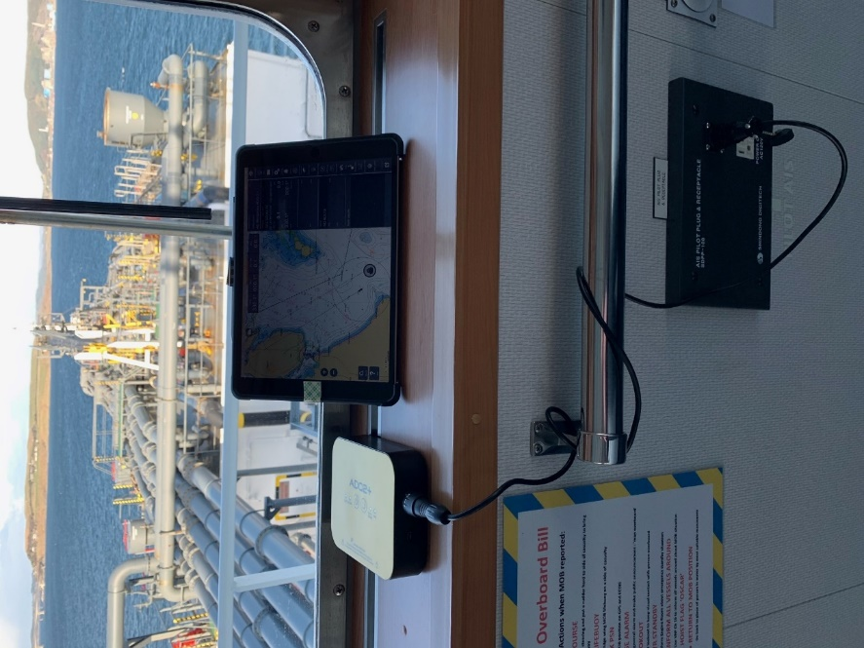
The pilot cannot trust the quality of the information they get via the ships' systems directly or by using the pilot plug. The pilots experience errors and offsets from the signal received from the pilot plug, which may contribute to an incorrect situational awareness (SA) amongst the navigators (master, pilot). These errors can be difficult to discover (offset on position often first seen when the vessel is alongside the quay).
The pilots also experience loss of signal from the pilot plug connector. Normally, this is a lower risk as you then clearly note that something is wrong, and he could neglect that specific system as input to his SA.
Picture 2. The system connected to the PP

The physical placement of the pilot plug connection point can constitute a practical challenge, e.g. if the pilot plug connection point on the bridge is placed in the back and “hidden” on the bridge.

Pilotage with small margins
Many of the elements mentioned under «regular pilotage» are also applicable to “pilotage with small margins”. One may argue that a “regular pilotage” with increased weather conditions or other unforeseen incidents quickly may turn into a “pilotage with small margins”.
Our description of “pilotage with small margins” is based upon assignments that either are outside standard pilotages, e.g. because of the size of the vessel in a given port, or are
F7 complex maritime operations that require months, and even years, of planning due to the complexity and number of participants involved.

These assignments are by nature slightly different than regular pilotages, as the pilots have more time and the possibility to bring along more equipment. There are normally several planning conferences in advance. Several pilots are often used for the same assignment repeatedly. Physical obstructions and indicators like buoys are put out in advance in order to assist in keeping clear of obstructions (shoals, no – go areas) in the fairway. The operations are often restricted to daylight, and can only be conducted within given “windows of opportunity” – for example, only in winds below 15 knots, currents under 0,5 knots, visibility above 1 nm.

In pilotage with small margins support tools are critical and necessary for the safe conduct of the operation, and an important tool when unforeseen incident occurs. These kinds of operations give new challenges in addition to the challenges given under regular pilotage:

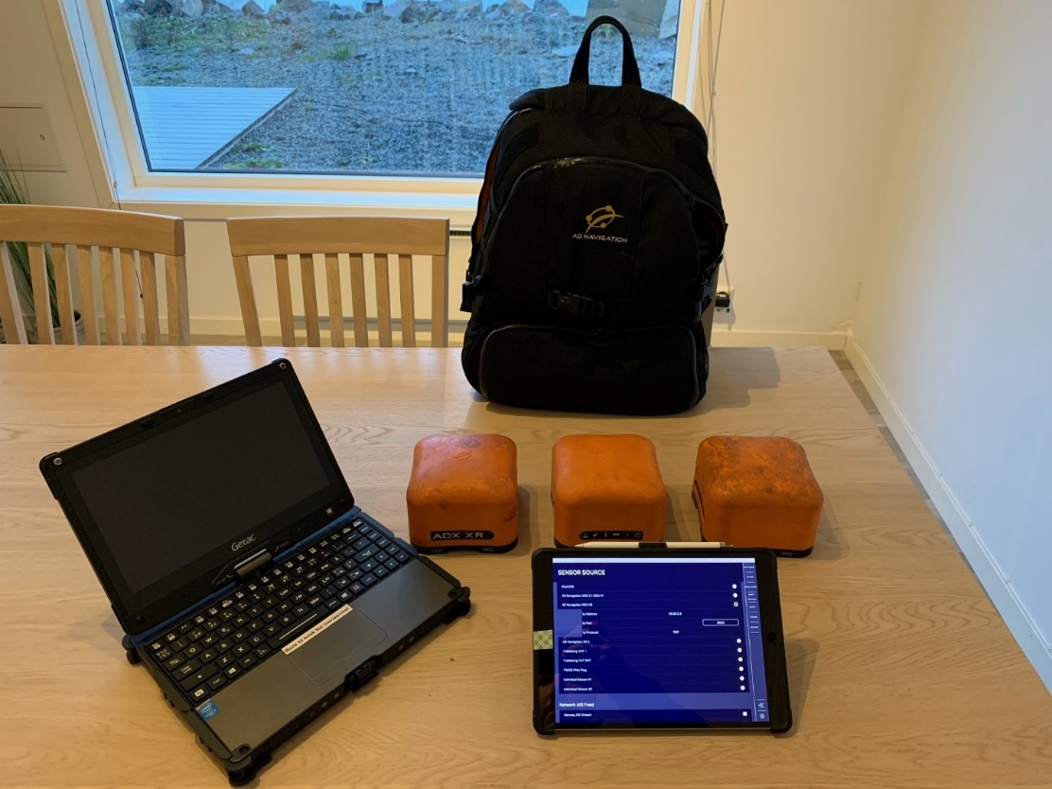
Picture 3. Independent sensors

Pilots have to depend on the system for the conduct of the assignment. The system becomes the pilot's primary tool for good SA. For example, assignments with vessels around 400 meters length, Pilots are not able to physically see the ships movement around the bow/stern area. Pilots therefore have:
- High expectations and requirement to accuracy. Practical need is often around 1 m.
- High expectations and requirement to stability (high mean time between failures) of the system. The system needs to remain operational for the duration of the assignment.
- To have a system that is smart enough and/or intuitive enough to detect that it is incorrectly placed by the users
- Use of time/cost and uncertainty towards quality of positioning of buoys and marking of obstructions in the fairway. Potential for human error in the process.

Remote navigational assistance by the pilot
Remote navigational assistance is conducted by a pilot when not physically embarked on the pilot seeking vessel. This operation is commonly known as “remote pilotage”, which by many is considered as giving navigational assistance for a constrained, defined area. However, in reality, a pilotage, also a remote pilotage, includes more than giving navigational assistance. It is also about preparations, manoeuvring recommendations of the vessel, giving information about berthing facilities/local regulations and most importantly, a proper cooperation/communication between master and pilot for the safe conduct of the passage.

Many of the elements mentioned under «regular pilotage» is also applicable to “remote navigational assistance”, and the important difference is that the pilot is not physically on board the vessel receiving assistance, with all the implications that entails.

The pilots use remote navigational assistance when weather (or other situations) inflicts possibility to embark on regular vessels. In can broadly be divided in two categories:

- A temporary situation for a restricted operation where the pilot eventually will board the vessel. A typical example would be an adverse weather situation on the boarding station, and the pilot initiates a procedure of remote navigational assistance in order to get the vessel to a more sheltered position.
- An assignment when the pilot would normally embark, but is not able to (for example by confirmed SARS-CoV-2 virus on board). Before conducting such an operation, there is a broad risk analysis meeting for that specific mission.

The pilot has to work from another (often smaller) vessel (e.g. a pilot boat). This often leads to harsh working conditions for the pilot. Very often the weather is rough, making working conditions on board the smaller vessel more complicated (see Picture 4).

In this setting the pilot meets some new challenges in addition to the ones mentioned earlier under “regular pilotage” and “pilotage with small margins”. The biggest challenge is that they lose the possibility to conduct traditional navigational control (optical and radar) of the position of the vessel and the voyage. In a smaller vessel thy do not have the visual overview as from a larger ship, and they are not able to get an impression how current, wind, weather and other external forces effect the ship. In addition the communication is often more difficult and, in some cases, insufficient. Appropriate information exchange between master and pilot is difficult due to lack of communication, especially body language and practical “walk throughs” of the plan/route and specifications of the vessel. The pilot is not able to verify that commands/advice from the pilot is understood and conducted correctly. There are delays in all parts of the information flow, which hampers efficient Bridge Resource Management (BRM), due to the physical distance. Finally, the pilot has no access to the on board system and is thus not able to utilize any of the information from ship systems / bridge instruments.

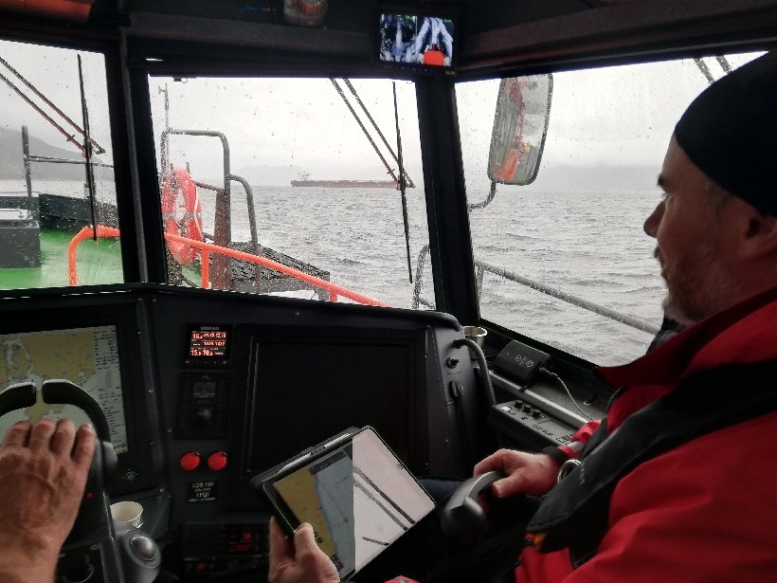
Picture 4. Remote navigational assistance

NCA Pilot Service thoughts on future systems
- Increased robustness compared to today’s systems
- Increased reliability compared to today’s systems
- Reduced number of potential sources of error, such as; faulty data, radio frequency interference (jamming, spoofing).
- Increased resilience for the vessels on board navigation system (independent and possibly redundant)
- Better integrity, based on more sensor fusion than today’s systems
- Increased adaptability to new technologies as they become available (modularity)
- Utilize the technological evolution within the maritime to aid the pilot to reduce risk in operation (integration of external data).
- Increased “user friendliness” (smarter) than today’s system.
- Contribute to increased readability and access to information (e.g. «Bird's View» approach to the overview of the vessel).
- Contribute to better use of high-resolution information (e.g. bathymetry and charts), and increased usage of this information in the operation.

The above mentioned are only NCA Pilot Service thoughts, and should not limit the supplier's innovation degree.

https://www.kystverket.no/en/EN_Maritime-Services/Pilot-Services/

