Invitation to dialogue conference
June 17th, 2020
Concept Verification -
Automated Baggage Handling (ABH)

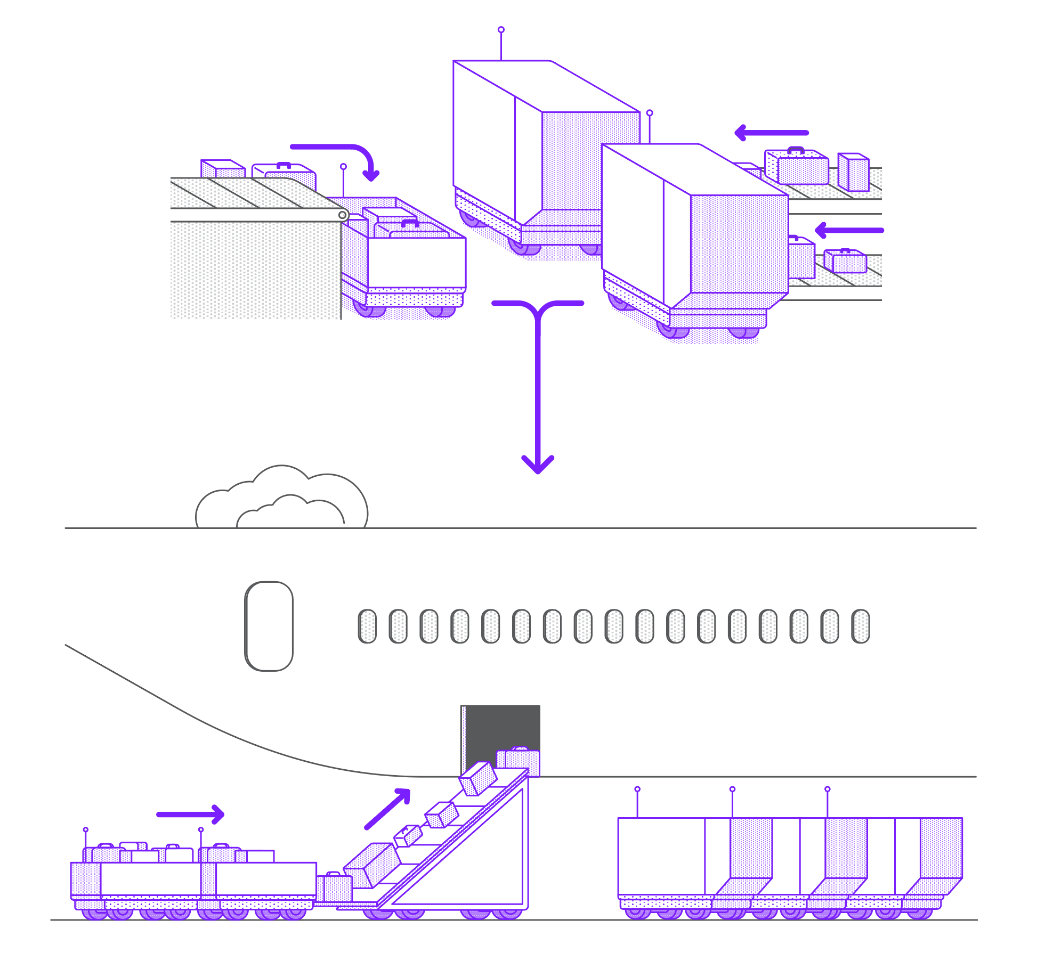
Dialogue to clarify potential for development of automated baggage handling

Avinor aims to improve and increase the efficiency of baggage handling in the “last-mile” and “first-mile” processes between the baggage handling system and the aircraft. We are therefore working towards the development of automated baggage handling involving the use of automatic loading of bags into trolleys and containers, automated indoor and outdoor transport, automated intermediate storage, and automated unloading from trolleys and containers.

Avinor organizes this activity with the project “Concept Verification - Automated Baggage Handling” (denoted ABH).

To identify the optimal solution and clarify potential and costs, Avinor invites possible suppliers and other key stakeholders to a web-based dialogue conference on
June 17th, 2020 at 12:00-14:00 (Oslo time).
There will be a common session where Avinor presents the activity and subsequent one-on-one meetings with interested suppliers, research groups and potential users. Registration and further information is located at www.avinor.no/abh.

About the dialogue conference

Target group

Suppliers or consortia who can supply all or parts of a solution for automating the mentioned baggage handling processes. Academic communities involved in relevant fields such as systematics, mechanical engineering, robotization, digitalisation, data processing and cybernetics.

What do we want to discuss during the dialogue?

Avinor aims to initiate the development of a solution for automatic baggage handling covering the departure processes of moving the baggage from the baggage handling system to the aircraft side, and the arrival processes of moving the baggage from the aircraft side to the baggage handling system. Such a solution will require various components to cover every step involved in automatic baggage handling. We discuss challenges on issues such as;
- Technical solutions currently available on the market
- Potential and limitations with current solutions
- The most significant challenges in developing automatic baggage handling
- The costs of developing a complete solution
- The cost of the final product
- The length of time required to develop such a solution
- The most appropriate areas of application for development
- Other approaches to the challenges than what have been described in this document

By inviting experts and suppliers/entrepreneurs to dialogue, we aim to clarify whether an automated solution for baggage handling using automated loading/unloading, automated transport and automated storage is technically possible and viable. We are also seeking dialogue with other users who require solutions for more efficient and improved baggage handling.

Avinor arranges a dialogue conference where companies are invited to present their approach to a solution for Avinor needs. Avinor will not convey received sensitive information to other parties and will enter an NDA if deemed necessary.

The described solution can be at an overall level, and the company are in no way committed to the input or solutions they present during dialogue or one-to-one meeting.

The conference will be online and commence with a common session where Avinor presents the project and responds to online questions from the participants. Thereafter there will be one-on-one sessions between Avinor and the interested participant.
Single point of contact: Wilhelm Otnes, Wilhelm.otnes@avinor.no, mobile (+47) 90749318.

Main purpose of potential procurement
Avinor will during Q4-2020 invite to prequalification and subsequent competition for the ABH project.

The main objective is to develop solutions for automatic baggage handling between the baggage handling system and the aircraft, in order to increase efficiency and improve working conditions for the handler agents.
Sub-goals:
- Develop an automatic bag loading mechanism for trolleys and containers (commonly denoted load carriers)
- Develop an automatic indoor transport service that transports load carriers between the loading station and an intermediate storage
- Develop an automatic storage for load carriers
- Develop an automatic outdoor transport service that transports load carriers between the intermediate storage and the aircraft side
- Ensure a seamless integration between the above, and an information system allowing control, monitoring, planning facilities, resource allocation and information interface to involved actors

Background

Airlines spends approximately 1 billion NOK per year on baggage handling services in Oslo airport alone. Since roughly 50 % of these costs are related to the baggage handling processes between the baggage handling system and the aircraft, there is a large potential for cost savings by automating part of these processes.

The current system for baggage handling is principally based on manual lifting of bags by baggage handling agents.

Bag are transported on trolleys or within containers

- Oslo airport has a common-use pool of approximately 750 trolleys, with an integrated baggage container and dolly.

- Containers are owned by the individual airline, where AKE and AKH type containers are handled at OSL. The container is transported on top of a separate dolly, where the dolly is owned by the handling agent.

The “last-mile” processes covers the final departure processes involving manual bag handling from the baggage handling system and the aircraft side:
- Bags received from the baggage handling system (BHS) into various sorting positions are manually scanned for identity and lifted into trolleys and containers for the particular flight.
- The trolleys and containers are then towed by a manned truck on top of their dolly to the side of the aircraft, where they await the loading into the aircraft.

- Bags are lifted manually from the trolleys into a belt loader conveyor transporting which transports them into the belly of the aircraft. Containers are loaded into the aircraft without use of manual lifting (by means of transporter and loader equipment).
The “first-mile” processes covers the initial arrival processes involving manual bag handling from the aircraft side and the baggage handling system:

- Bags are lifted manually into the trolleys from a belt loader conveyor transporting them from the belly of the aircraft. Containers are unloaded from the aircraft without use of manual lifting (by means of transporter and loader equipment).
- The trolleys and containers are towed by a manned truck on top of their dolly from the side of the aircraft to the baggage handling system.

- Bags are lifted manually from the trolleys and containers and loaded into the baggage handling system.
The manual handling is a time-consuming and expensive process and has to a large extent been unchanged during the last 50 years. There is a major requirement for improving and increasing the efficiency of baggage handling in these areas.

In recent years, there has been significant developments of robotics, warehouse technologies and autonomous vehicles that allows automatic handling of parcels from reception, storing, and transporting these autonomously between entities. However, this technology has not yet been adapted with success to the domain of airport baggage handling.

Nationwide and internationally, there is a significant need for improving efficiency and improving working conditions for baggage handling. An automated process chain will increase the efficiency and reduce the manual lifting of baggage. Automatic transport will also reduce the number of accidents and damage to personnel, buildings and equipment both indoor and outdoor.

Oslo airport will facilitate the development of automated baggage handling by building a Concept Verification Centre of approximately 1500 m2, where vendors will be invited to test and refine new concepts. The ultimate goal is to purchase and commission the accepted solutions into production towards 2025 when a new baggage handling system will be ready for production.

Description of needs and function
Avinor aims to develop a comprehensive system with optimal automation of baggage handling between the baggage handling system and the aircraft stand, covering both departure and arrivals. The mandate is to automate as much as possible within these processes.

The comprehensive departure system can be divided into five main parts (as illustrated in figure 1 below);
- Automatic loading of bags into trolleys and containers
- Automatic indoor transport of trolleys and containers
- Automatic storage and retrieval of trolleys and containers
- Automatic outdoor transport of trolleys and containers
- Automatic transfer of loose bags onto conveyor belt

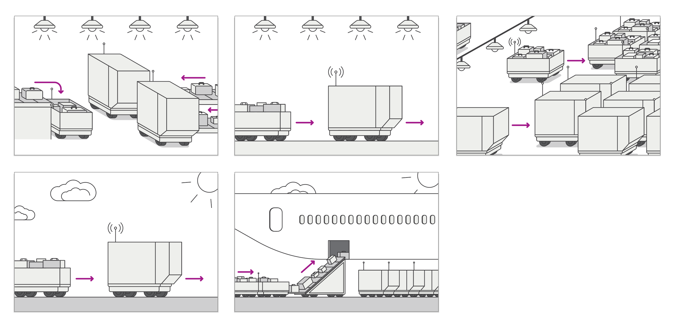
Figure 1. Illustrates the different steps of automatic departure last-mile baggage handling. The first image illustrates automatic loading of bags from the baggage handling system into trolleys and containers. The trolleys and containers are transported indoors by autonomous devices to an intermediate storage. Eventually the trolleys are automatically retrieved and transported to the aircraft stand by outdoor autonomous devices. Bags are automatically transferred onto belt conveyors which transport them into the aircraft, while containers are moved into the aircraft by using existing infrastructure.

The comprehensive arrival system can be divided into three main parts (as illustrated in figure 2 below);
- Automatic transfer of loose bags into trolleys
- Automatic outdoor transport of trolleys and containers
- Automatic unloading of bags from trolleys and containers

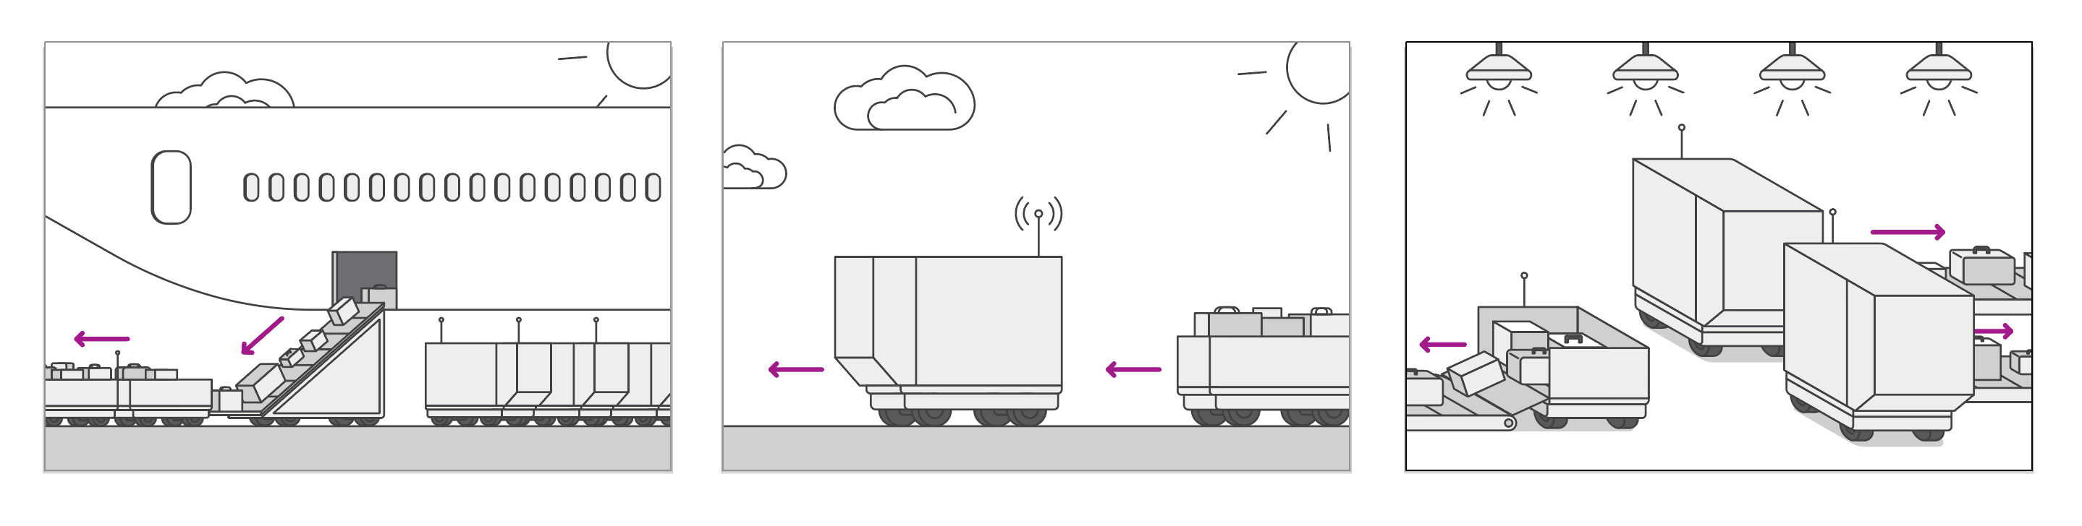

Figure 2. Illustrates the different steps of automatic arrival first-mile baggage handling. The first image illustrates retrieving trolleys and containers on dollies at the aircraft stand, where bags are automatically transferred into trolleys and containers are lifted onto dollies by using existing infrastructure. The trolleys and containers are then transported outdoors to a loading station by an autonomous vehicle. Thereafter the bags are automatically loaded into the baggage handling system.

An IT system providing seamless control, monitoring, planning facilities, resource allocation and information interface to involved actors will be needed for the above-mentioned processes.

Potential benefits – relevant areas of application
Automatic baggage handling will provide substantial benefits for airlines, handling companies, Avinor and the individual currently engaged in heavy manual work.

Improvements will be of use to other airports in Avinor, as well as airports worldwide.

Information on innovation procurement

Oslo Airport will define a scheme where providers can compete for a development fund, which will be allocated to selected applicant groups. A subsequent procurement will then be initiated, provided that the proposed solutions fulfil the defined needs.

The dialogue conference on June 17th will focus on the needs and will only provide high-level information on the procurement process itself. The second part of the dialogue conference will be arranged in early September (date to be announced), with focus on the procurement process itself.

Avinor
Telephone: (+47) 67 03 00 00
Email: post@avinor.no
Website: www.avinor.no
Post: Avinor AS, Postboks 150, 2061 Gardermoen
Address for visitors, Oslo: Oslo Atrium, Dronning Eufemias gate 6, 0191 Oslo

Avinor is a wholly owned state limited company under the Norwegian Ministry of Transport and Communications and is responsible for 44 state-owned airports.
Over 3000 employees are responsible for planning, developing and operating an efficient airport and air navigation service. Avinor is financed via airport charges and commercial sales. The air navigation service is organized as a wholly owned subsidiary by Avinor. Avinor's headquarter is in Oslo.

Oslo airport (OSL) is the largest airport of Avinor and the largest airport in Norway, serving as a hub for the other Norwegian airports. OSL handles approximately 30 million passengers per year, of the total 55 million passengers per year in Avinor.

